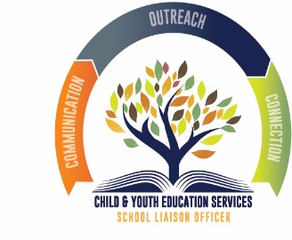

NAS OCEANA/DAM NECK ANNEX &
MIDWAY MANOR
CHILD & YOUTH PROGRAMS

YOUTH SPONSORSHIP CHECK-OUT PROCESS

- Name of family in transition: ______________________________________________________

- Age of child(ren): ________________________________________________________________

- Interested in signing up for the Youth Sponsorship Program: Yes: ________ No: _________

- If yes, please ask for a “point-of-contact” assistance from our staff.

YOUTH SPONSORSHIP CHECK-IN PROCESS

- Name of family: ________________________________________________________________

- Age of child(ren): ________________________________________________________________

- Contact Youth Sponsorship Program: Yes: _______ No: _______

- Contact School Liaison Officer: Yes: ________ No: ________

To assist us with marketing our program, how did you become aware of us?
  - FB page
  - MWR web site
  - Friend, family or coworker
  - MWR Event
  - Indoc./Command
  - Child & Youth Programs (which one):________________________________________
  - Other: ________________________________________________________________

